**SCS2202/IS2102 - Group Project I**

**2020**

**Project Proposal**

for

**Hotel Management System**

Prepared by CS Group -29

## Proposed Project Supervisor (Academic Staff of UCSC):

Name of the supervisor: Mr. Rangana Jayashanka

Signature of the supervisor: rja

Date: 2020/05/22

## Proposed Project Co-Supervisor (Assigned by Course Coordinator):

Name of the co-supervisor: Ms. Kamsa Sharma

Signature of the co-supervisor: nsk

Date: 2020/05/22

## The client of the Project (If applicable, otherwise supervisor will be considered as the client)

Name of the client: Mr. Indigahawalage Sudeera

Address of the client:502 bypass road, Weligama

Contact person at the client:

The contact number of the contact person: +94 76 729 3945

email address of the contact person: [bayfrontweli45@gmail.com](mailto:bayfrontweli45@gmail.com)

Table of Contents

Introduction to Project 3

Project Goal 4

Objectives of the project 4

Scope of the project 4

Project scope identification and clear boundaries 4

Out of Scope 5

Clear on assumptions 5

Project Feasibility 5

Technical Feasibility 5

Operational Feasibility 6

Economic Feasibility 6

Schedule Feasibility 6

Legal Feasibility 6

Deliverables of the project 6

Functional Requirements Identification 7

Component diagram 7

Use case diagrams 8

System actors identification 9

Use Case Description 10

Activity Diagram 23

Quality Attribute Identification 37

Identification of Quality Attribute 37

Suggestions to achieve Quality Attribute 37

Technologies to be used 37

Front-end 37

Back-end 37

Other technologies 38

Project timeline 38

Declaration 38

# Introduction to Project

The hotel industry plays a vital role in the tourism industry. Technology usage in the hotel industry is advancing. Today Hotel Management system application is essential equipment to improve the business. Our client wants to solve existing problems using a hotel management system.

The client is currently using websites such as booking.com, trip-advisor.com, ahotel.com, agoda.com, and a template from booked.net. Owning an independent website is not a must, but sometimes it may occur some problems. Intermediaries like Corporate websites and travel agencies demand commissions around 20% of the profits. This might not make sense for large scale hotels, but it impacts on medium and small-scale hotels.

A hotel website is a source of information for guests. With their website, hotels control the exact content and images that the hotel wants to use in the market. There are no limits in the number of photos, room types, pages, or length of content. This increases the opportunity to drive more traffic to the website. After location, images are the number one factor that guests consider when choosing a hotel. We can use introductory videos to make guests aware and allow them to imagine themselves at the property. The Owner can display promotional packages. The commission-free direct bookings are financially benefitted to both hotels and customers. Customer can get their queries to solve quickly by directly communicating with the site. All these factors help in building customer loyalty towards the hotel.

When registering walk-in guests, the front desk staff hands over the GRC (Guest Registration Card) to fill the information. The client has to fill it manually if there is no system. Suffice to say this is a quite cumbersome practice. Taking up a lot of space, these documents can be damaged, lost, or misplaced in numerous ways. If or when these details are damaged, they are almost unsalvageable. It is tedious to make changes.; a copy has to be made in making any changes to save the originality. It is very hard to access the file unless it is well organized. This can annoy customers as well as employees. This lowers productivity. Further, manual documentation has much less security than digital documentation.

The system we provide includes a digital documentation solution. This allows us to search and retrieves needed files immediately. By digitalizing documents, it will be completely searchable, and the security of the information is much better. This allows making aware frequent walk-in guests about seasonal offerings and discounts through emails.

Usually, payments are made manually using the invoice book. This may financially problematic If the client is absent. We introduce a payment management system that allows online payments is beneficial in preventing financial irregularities. Most customers prefer online payment as it saves time, and it secure and convenient.

The client and employees do not have high IT literacy. So, the system should be simple, and the website should be easily manageable. We hope to use a simple, user-friendly interface to outcome this.

The client needs to maintain the details of the employees. The system provides the facility too.

# Project Goal

* The main goal of this project is to make a secure online environment for hotel management.
* We are creating a web-based system for our clients in order to maintain good customer relationships.

# Objectives of the project

* To manage the hotel using a computerized system.
* The system should support a multi-user environment.
* Real information on the availability of the room.
* To make efficient and effective use of the hotel system.
* To provide a web site that allows customers to search and reserve a hotel room or cancel his/her reservation over the internet at any time.
* To manage large volumes of data to acquire timely and accurate information

# Scope of the project

## Project scope identification and clear boundaries

1. Customer Registration

* Details Login or Facebook Login and Google Login

1. Room Reservation System

* Room Cancelation (only Free Cancel Only)

1. Notification System

* Online Customer Reservation: After booking or reserving a surfing package, details are sent to the Owner and receptionist. After confirmation, notification is sent to the guest.
* Walk-in Guest Reservation: Guest and Owner both receive notification after a booking is confirmed.
* Payment
  + Online: Owner, receptionist, and Guest and receive notifications.
  + Cash: Owner and Guest receive notifications.

1. Edit Site System

* Room prices and type can be changed. The Owner can edit discounts for rooms, Surfing Package. The Owner can add or update images on website price can be changed, and discounts can be offered through the website.

1. Manage Employee

* The Owner can add, delete, or change employee details only.

1. Write Feedback

* Only check-out customers can review, and one guest can leave only one review.

## Out of Scope

* System Advancement due to the addition of future branches.
* The system can be used only to add, delete, or modify employee details. It can not be used to do any other things, like taking employee mark attendance or assigning short leave.

## Clear on assumptions

* No one makes the same reservation at the same time from different websites.
* Every probable Customer has an email address.
* When the receptionist finishes work, the Owner has to take care of the receptionist's work. So the receptionist's use cases should be enrolled to the Owner.

# Project Feasibility

## Technical Feasibility

* The project can be done by using existing technologies.
* Current technical resources can be upgraded to provide the level of technology necessary for the system.
* The team is equipped with the knowledge and expertise needed to develop the system using current technologies.

## Operational Feasibility

* The system is to provide adequate throughput and response time.
* The system allows the receptionist/owner to adapt without any specialized training with no time. This is a user-friendly system that makes it easy for the Customer.
* The report generating feature provides a report accurate and useful formatted information from the system.

## Economic Feasibility

* Free and open source technologies are used in developing this system.
* Even though at the beginning domain, hosting and maintenance will need some expense, the benefits from the system outweigh the cost.
* The system is very much affordable.

## Schedule Feasibility

* We have planned and scheduled hoe and when we are going to implement each part of the system.
* We will most certainly be able to implement the system within the estimated period, and it is shown in the Gantt chart shown below.

## Legal Feasibility

* Most of the technologies used will be free and open source. If not, they will be used with proper copyright.
* The privacy of the information obtained from customers/guests are well kept. They will not be visible or accessible to any unauthorized parties or will not be used for, and advertising purposes with the expressed permission from the Customer.
* A password or any biometric identification will be used to prevent any unauthorized access to the system. Proper user privileges will be set for the groups or individuals
* The team will make sure that the execution of the system does not breach any laws of this country. It will be done with the ultimate regard to meet ethical & legal requirements.

# Deliverables of the project

* We deliver a web application responsive to Desktop, Tablet, and smartphones.
* It has an attractive and understandable user-friendly interface.
* We also provide the client with a user manual(documentation) on how to handle the system.

# Functional Requirements Identification

## Component diagram

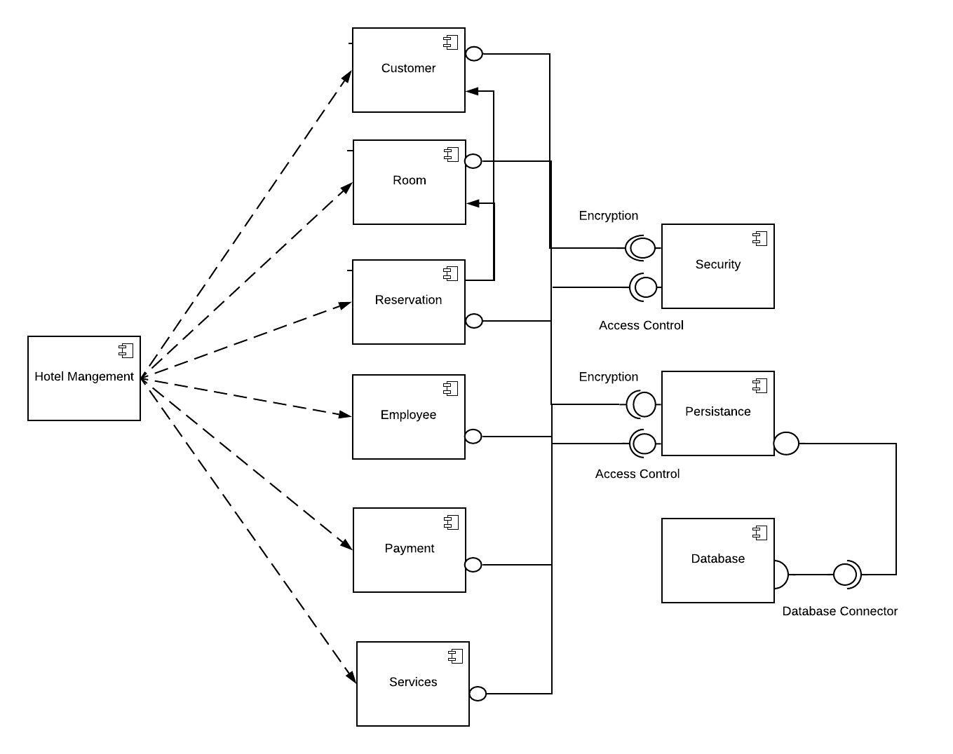

## Use case diagrams

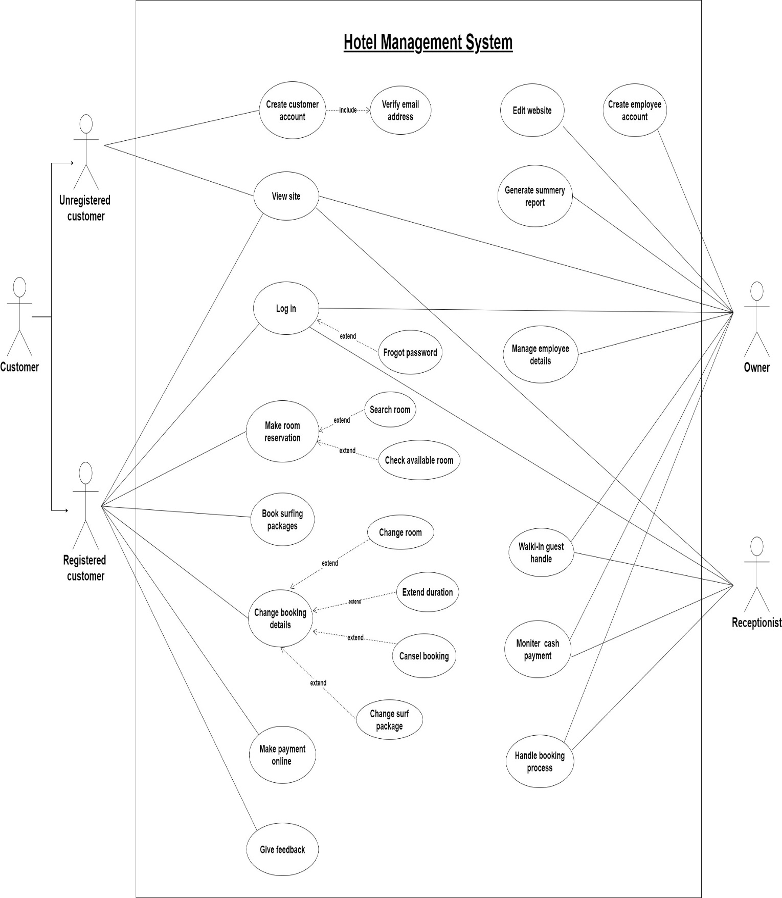

## System actors identification

Unregistered Customer

* Create customer account
* It can only access the static web pages on the web application.
* Home
* Rooms & suites
* Dining
* Surf packages
* Gallery
* About us
* Contact
* Guest review

Registered Customer

* Log in website
* It can access the static web pages on the web application.
* Reserving room
  + Ability to cancel the booking
  + Ability to change room
  + Ability to extend the reservation period
* Reserving surfing package
  + Ability to change package
* Online payment facilities
* Give feedback

Receptionist

* Log in website
* It can access the static web pages on the web application.
* Handle the walk-in guest
* Monitor the cash payment
* Handle the booking process

Owner

* Log in website
* It can access the static web pages on the web application.
* Handle the walk-in guest
* Monitor the cash payment
* Handle the booking process
* Edit the website
* Manage employee details
* Generate summary reports

## Use Case Description

|  |  |
| --- | --- |
| **Use case** | **View site** |
| **Summary** | The Customer can get more details through the website. |
| **Actor** | Unregistered Customer  Registered Customer  Owner  Receptionist |
| **Preconditions** | None |
| **Description** | Anyone can get more details about the hotel.  The website gives the following details.   1. 1.Room details. 2. 2.Hotel environment and facilities. 3. 3.Hotel room packages and discounts. 4. 4.Images 5. 5.Surfing packages details. 6. 6.Customer reviews. 7. Restaurant item details. |
| **Exceptions** | None |
| **Post Conditions** | None |

|  |  |
| --- | --- |
| **Use case** | **Create customer account** |
| **Summary** | User registers with the system. |
| **Actor** | Unregistered Customer |
| **Preconditions** | Customer clicking sign up button and opening sign up form.  Customers must agree with the terms and policies. |
| **Description** | The user will create an account entering below details,   * First name * Last name * Email address * password   after that, the Customer submits their data. |
| **Exceptions** | Users can't create accounts if users enter invalid or already entered email addresses. |
| **Postconditions** | Now users have grant privileges to booking and else. |

|  |  |
| --- | --- |
| **Use case** | **Verify email address** |
| **Summary** | The process is to verify customers by using an email address. |
| **Actor** | Unregistered Customer |
| **Preconditions** | The Unregistered Customer must create an account. The Unregistered Customer must have an email address. |
| **Description** | Without an account, customers can't make any reservations. Then they create an account, and the entered email address needs to be verified.  The Customer gets his verified code, and he can enter it correctly verify the account. |
| **Exceptions** | If Unregistered customers entered an invalid email address, they can't get verification code. |
| **Post Conditions** | Unregistered customers can create an account. |

|  |  |
| --- | --- |
| **Use case** | **Login** |
| **Summary** | User users the account created by the system to log in to the system. |
| **Actor** | Unregistered Customer  Registered Customer  Owner  Receptionist |
| **Preconditions** | The user must create an account and give valid account details to access the system. |
| **Description** | Users will log in using the ID and the password given during registration. |
| **Exceptions** | If the user forgets a password, it can be renewed using a verification code provided by the system. |
| **Postconditions** | Users can access the system. |

|  |  |
| --- | --- |
| **Use case** | **Forgot Password** |
| **Summary** | The System provides a method for when the user forgets the user password and doesn't want to create another account. |
| **Actor** | Registered Customer  Owner  Receptionist |
| **Preconditions** | The user must be a registered customer/Receptionist/owner |
| **Description** | The user forgot their password. The system first verifies the user by sending OTP by System to the user's provided email address. Then user types that OTP code. After that user can change the password. |
| **Exceptions** | The user can't get verification code the provided email. |
| **Post Conditions** | The user can access the system |

|  |  |
| --- | --- |
| **Use case** | **Make room reservation** |
| **Summary** | Unregistered and registered customers can reserve hotel rooms. |
| **Actor** | Registered Customer |
| **Preconditions** | Enter the valid check-in and check-out Date/Number of Adults/Number of Rooms and should be a registered customer. |
| **Description** | Any Customer can view room details. But only registered Customers can make a reservation.  Once accurate details are entered, let them search for a room they prefer. |
| **Exceptions** | If Customer can't make a reservation, should create an account first. And also, Customers can't make reservations when rooms are not available at that moment. |
| **Post Conditions** | The Customer received room reservation confirmation notification. |

|  |  |
| --- | --- |
| **Use case** | **Search Room** |
| **Summary** | The Customer can find rooms to their preferences from the website(e.g., seaside room) |
| **Actor** | Unregistered Customer  Registered Customer |
| **Preconditions** | The Customer must give their check-in and check-out date /number of adults/number of rooms |
| **Description** | The Customer will search for their room category by entering details.  1. Beach-side  2.room type(single/double/king size)  3.room facilities(ac non ac/free wifi) |
| **Exceptions** | The Customer can only search while making reservations. |
| **Post Conditions** | Customers can continue the reservation process. |

|  |  |
| --- | --- |
| **Use case** | **Check Available Room** |
| **Summary** | The Customer looks for available rooms after entering check-in and check-out details. |
| **Actor** | Unregistered Customer  Registered Customer |
| **Preconditions** | The Customer must give check-in and check-out dates/number of adults |
| **Description** | The Customer can make reservations by selecting rooms using a check Available room list. |
| **Exceptions** | The Customer can only search while making reservations. |
| **Post Conditions** | Customers can make reservations. |

|  |  |
| --- | --- |
| **Use case** | **Make online payment** |
| **Summary** | To pay for the room reservation and surfing packages bills via the website. |
| **Actor** | Registered Customer |
| **Preconditions** | The system has information about room and surfing packages booked by Customers. |
| **Description** | The Customer filled the payment details, such as.   * Cardholder Name * Card Number * Card Expiration * Security Code (CVV)   Then Customer select 'make payment' to continue the transaction on this payment. |
| **Exceptions** | Invalid payment information: Customers re-enter correct payment information. |
| **Postconditions** | Customer. The owner and receptionist gave the transaction successfully notification. |

|  |  |
| --- | --- |
| **Use case** | **Writing Feedback** |
| **Summary** | The Customer can review the hotel after check-out. |
| **Actor** | Registered Customer |
| **Preconditions** | The customer must check-out before reviewing. |
| **Description** | The registered Customer has to log in.  Can add some review about the hotel when check-out. |
| **Exceptions** | One user is allowed to leave only one review. |
| **Post Conditions** | Display feedback on the website. |

|  |  |
| --- | --- |
| **Use case** | **Book Surfing packages** |
| **Summary** | The registered Customer can book surfing packages via the site. |
| **Actor** | Registered Customer |
| **Preconditions** | The user must be a registered customer and logged-in and must have made a room reservation. |
| **Description** | The Registered Customer will Book surfing packages using him/her verification.  Booking Surfing packages using  1.User name  2.Password  3.Surf Package details  4.Surf Package amount |
| **Exceptions** | If Customer can't Book Surfing packages, he isn't logged in and didn't make a reservation in the hotel. |
| **Post Conditions** | Registered Customer has to wait for the Book Surfing package confirmation message. |

|  |  |
| --- | --- |
| **Use case** | **Change Booking Details** |
| **Summary** | Registered Customers can update reservation details. |
| **Actor** | Registered Customers |
| **Preconditions** | The Customer must have made a room reservation.  When re-allocating rooms or extending stay, the user must search and select available rooms. |
| **Description** | Registered Customer can Update room details like Change room, extend the room reserve duration, and cancel the room. |
| **Exceptions** | If the login details are invalid, the user is requested to re-enter login details.  If there are no available rooms, the user cannot update room details.  Some rooms do not support free cancellation. In this case, the Customer is not allowed to cancel the room, which already booked. |
| **Post Conditions** | The Customer received an update confirmation notification. |

|  |  |
| --- | --- |
| **Use case** | **Change Room** |
| **Summary** | The Registered Customer can change rooms they booked. The system updates changed details. |
| **Actor** | Registered Customer |
| **Preconditions** | The Registered Customer must have made a room reservation. |
| **Description** | The registered Customer will give room details  1.Check-in date  2.Check-out date  After customers can show available rooms that date, then they can select a new Room. |
| **Exceptions** | The Customer can't change the room if every room is booked.  The Customer can't change the room if he's not logged in. |
| **Post Conditions** | The Customer has to wait for a change room reservation confirmation message. |

|  |  |
| --- | --- |
| **Use case** | **Extend duration** |
| **Summary** | The Registered Customer can extend the stay. The system updates changed details. |
| **Actor** | Registered Customer |
| **Preconditions** | The Registered Customer must have made a reservation. |
| **Description** | The registered Customer will give room details  1.Check-in date  2.Check-out date  3.New Check-in date  4.New Check-out date  After customers can show available rooms that date, then they can select a new Room. |
| **Exceptions** | The Customer can't extend reserved time if he is not logged-in.  Customers can't extend reserved time if every room is booked. |
| **Post Conditions** | The Customer has to wait to extend the room duration confirmation message. |

|  |  |
| --- | --- |
| **Use case** | **Cancel Booking** |
| **Summary** | The Registered Customer can only cancel reservations within the given conditions. The system updates changed details. |
| **Actor** | Registered Customer |
| **Preconditions** | The Customer can cancel bookings if only it is allowed.  The Registered Customer must have made a reservation. |
| **Description** | He or she agreed given conditions they can confirm their cancelation. |
| **Exceptions** | The Customer can't cancel a room booking if he is not logged-in.  The Customer can't cancel the booking if the booked room is not allowed to be canceled. |
| **Post Conditions** | The Customer has to wait for a canceled room booking cancelation message. |

|  |  |
| --- | --- |
| **Use case** | **Change Surfing Packages** |
| **Summary** | The Registered Customer can change surfing packages by updating booking details. The system updates changed details. |
| **Actor** | Registered Customer |
| **Preconditions** | The Registered Customer must make a reservation in the hotel. The Registered Customer is given Surfing details |
| **Description** | The registered Customer will give room details  1.Check-in date  2.Check-out date  Showing available packages and customers can select a new package as they wish. |
| **Exceptions** | The Customer can't change surf packages if he isn't logged-in.  Customers can't change surf packages if every surf package is booked. |
| **Post Conditions** | The Customer has to wait to change the surf package confirmation message. |

|  |  |
| --- | --- |
| **Use case** | **Monitor a cash payment** |
| **Summary** | To pay for the room reservation and surfing packages bills to cashier. |
| **Actor** | Owner  Receptionist |
| **Preconditions** | The system has information about room and surfing packages booked by Customer  The receptionist should be logged into the system. |
| **Description** | The Customer asked the payment details in the receptionist.  Then the receptionist asks customer details to search the payment details that Customers using the system.  Then the Customer makes payment to the receptionist, and then the receptionist enters that payment details in the system. |
| **Exceptions** | Invalid customer details: receptionist ask again and re-enter customer details. |
| **Postconditions** | Customer. The owner and receptionist gave successfully make payment notification. |

|  |  |
| --- | --- |
| **Use case** | **Walk-in guest handle** |
| **Summary** | Some guests are coming to the hotel without a web site. They can reserve room and surfing packages at the front desk. |
| **Actor** | Owner  Receptionist |
| **Preconditions** | The receptionist must be log to the system. |
| **Description** | Walk-in guests can require about rooms.  Receptionist check available rooms and inform the Customer.  Get customer details and make customer registration. |
| **Exceptions** | If there are no available rooms at that moment, can't make a reservation |
| **Postconditions** | The system must give confirmation notification to the Customer and also the receptionist. |

|  |  |
| --- | --- |
| **Use case** | **Handling the booking process** |
| **Summary** | The receptionist can update room details and surfing package details of the hotel through the system. |
| **Actor** | Owner  Receptionist |
| **Preconditions** | The user must be logged in.  Booking must be made from another site.  The Customer must request to modify the room details. |
| **Description** | The user handle rooms and room reservation.  When a booking comes from another site, the receptionist or the Owner must close the reserved room or rooms.  Users have to handle requests to modify room details or to extend the duration.  Users have to handle cancellation requests.  1.Close room  2.Other booking site reservation  3.Walk-in guest reservation |
| **Exceptions** | If the receptionist can't handle the booking process, he isn't logged-in.  The room expected by the Customer is already booked. |
| **Post Conditions** | The web site is updated according to new booking details. |

|  |  |
| --- | --- |
| **Use case** | **Create an employee account** |
| **Summary** | The Owner keeps the details of every employee of the hotel. |
| **Actor** | Owner |
| **Preconditions** | The Owner must be given employee details. |
| **Description** | The Owner will create an employee account with the given details.  Create an account using:   1. First name 2. Last name 3. Birthday 4. gender 5. Email address 6. Mobile number 7. Emergency contact number 8. Basic salary |
| **Exceptions** | If the owner can't create an employee account, he isn't logged-in. |
| **Post Conditions** | The system gets employees' details, and the responsible personnel gets access to the system. |

|  |  |
| --- | --- |
| **Use case** | **Manage employees** |
| **Summary** | The user modifies employee details. |
| **Actor** | Owner |
| **Preconditions** | User must be logged in as Owner |
| **Description** | Users can add, modify, and delete employee details. |
| **Exceptions** | If a login error occurs, the user is expected to reenter login details and retry. |
| **Postconditions** | The database should be updated. |

|  |  |
| --- | --- |
| **Use case** | **Edit Website** |
| **Summary** | The user gets the privilege to edit site details. |
| **Actor** | Owner |
| **Preconditions** | The user must be logged in as the Owner. |
| **Description** | User can modify the following room details.   1. Price 2. Discount 3. Images 4. Room type 5. Room facilities   User can modify surfing package details. |
| **Exceptions** | If a login error occurs, the user must re-enter login details and retry. |
| **Postconditions** | The site should be updated.  The database also should be updated.  A message should be displayed, telling that the site is updated. |

|  |  |
| --- | --- |
| **Use case** | **Generate a summary report** |
| **Summary** | The owner may want a report on the overall performance of the system between a specific period.  So the Owner can get reports through the system. |
| **Actor** | Owner |
| **Preconditions** | The owner must be login to the system and is allowed to access the database. |
| **Description** | The owner gets access to the database.  Selects information to generate the report   1. customer details 2. room details 3. employee details 4. booking progress 5. income |
| **Exceptions** | none |
| **Postconditions** | Summary report from the database is generated, Then Owner can view it. |

## Activity Diagram

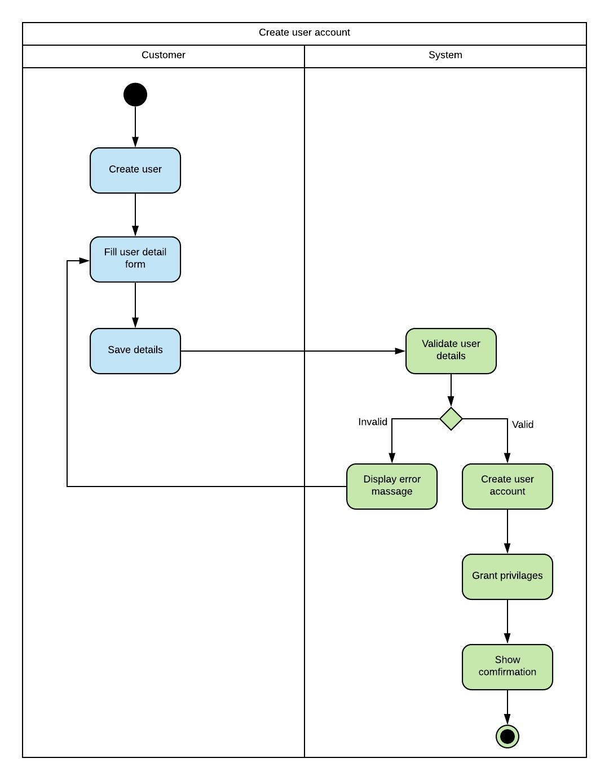

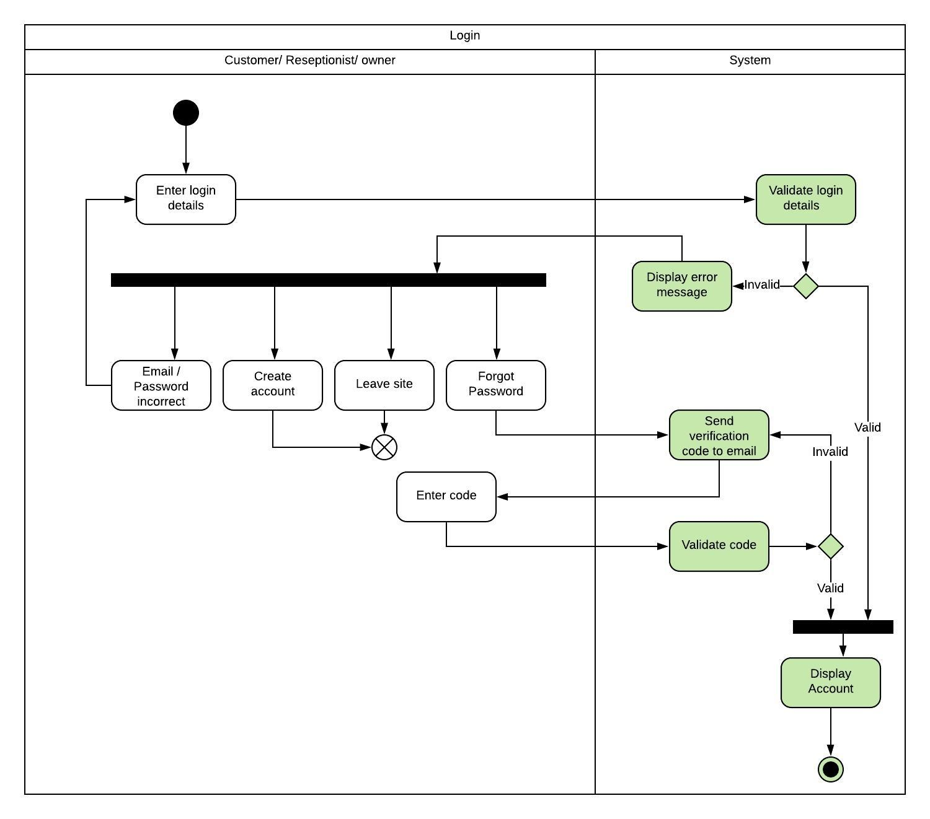 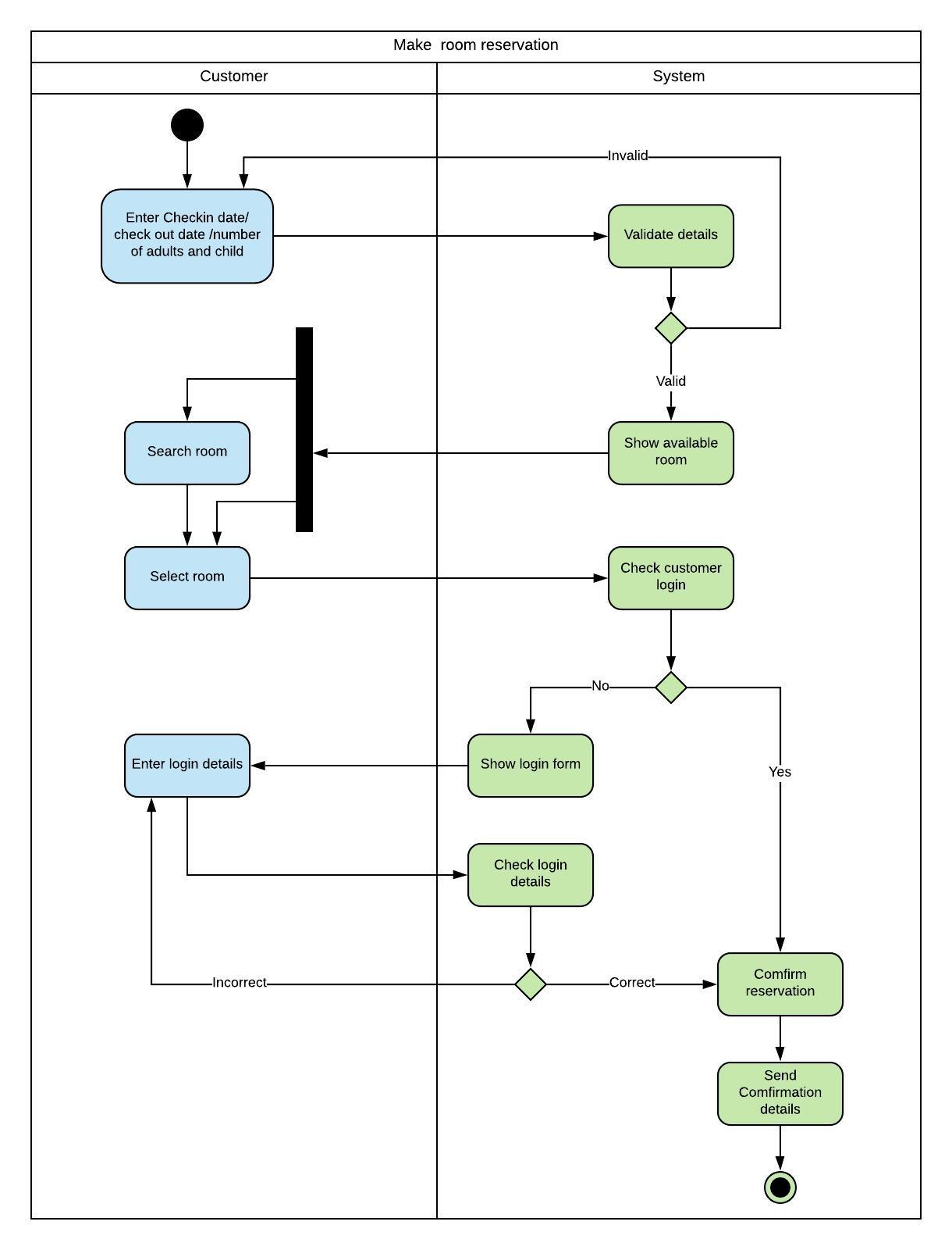

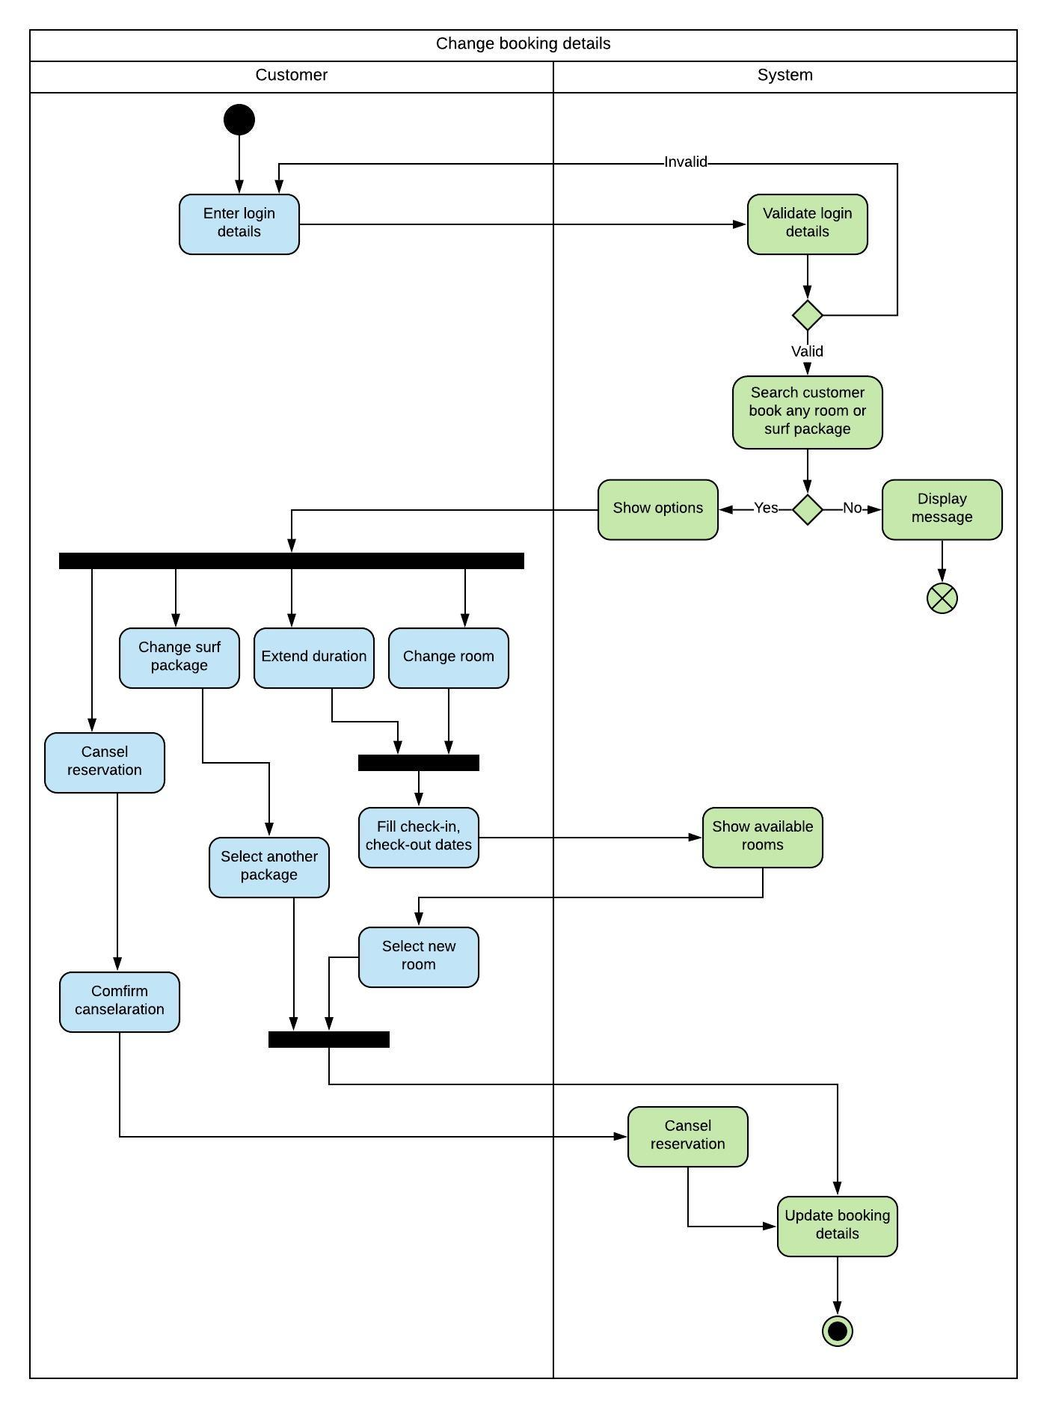

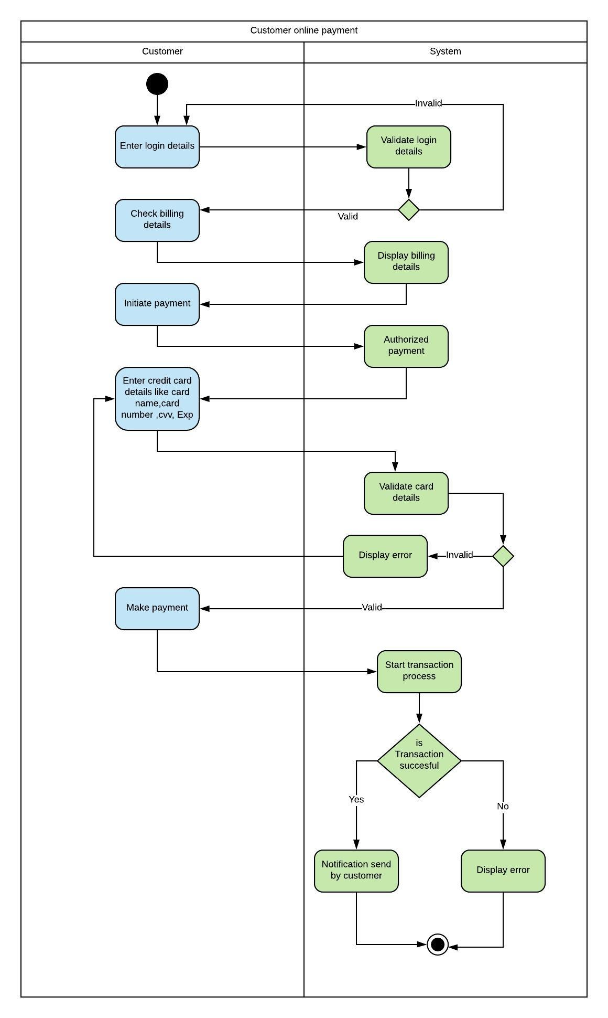

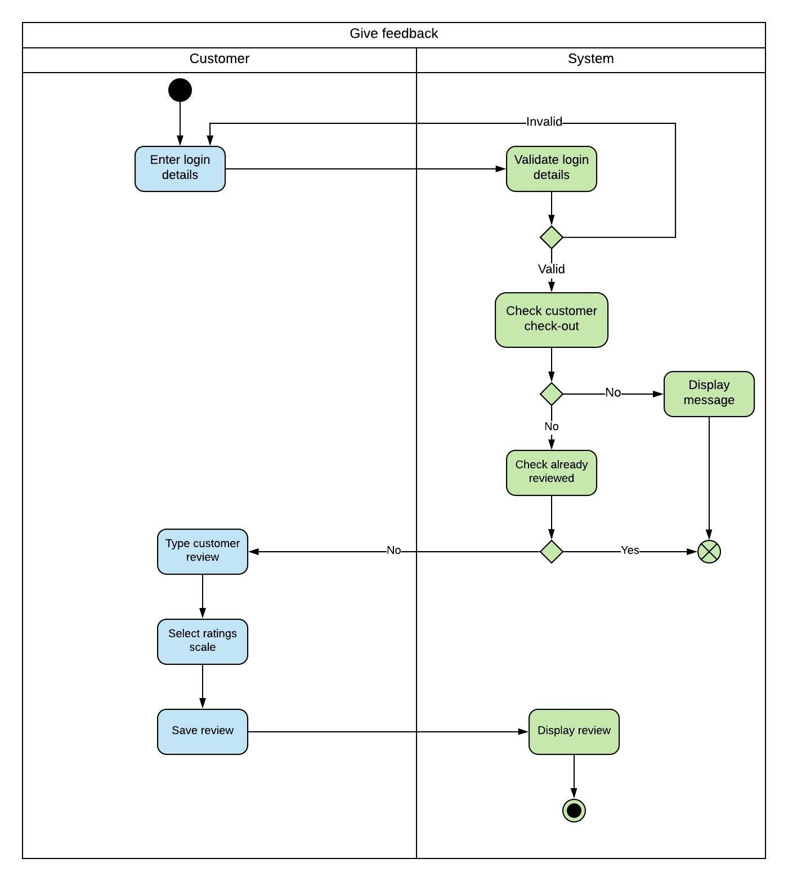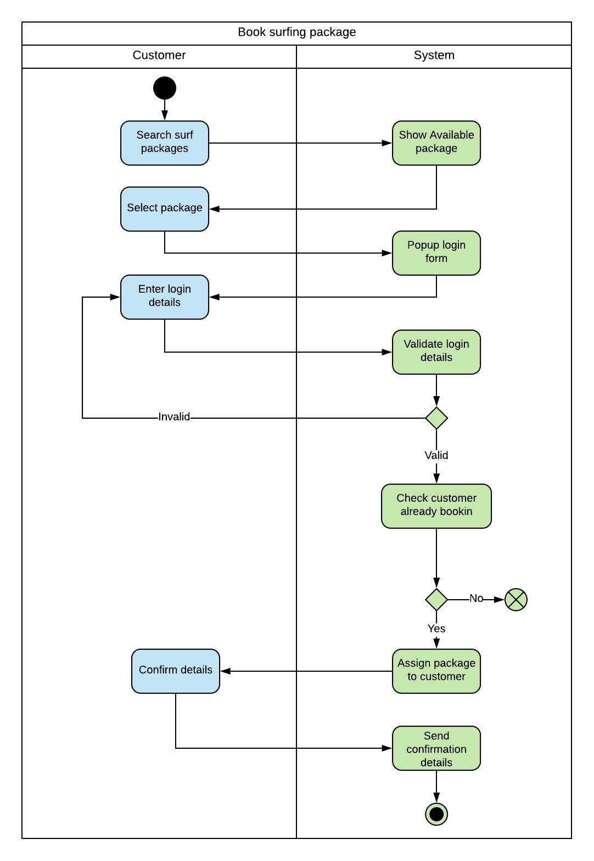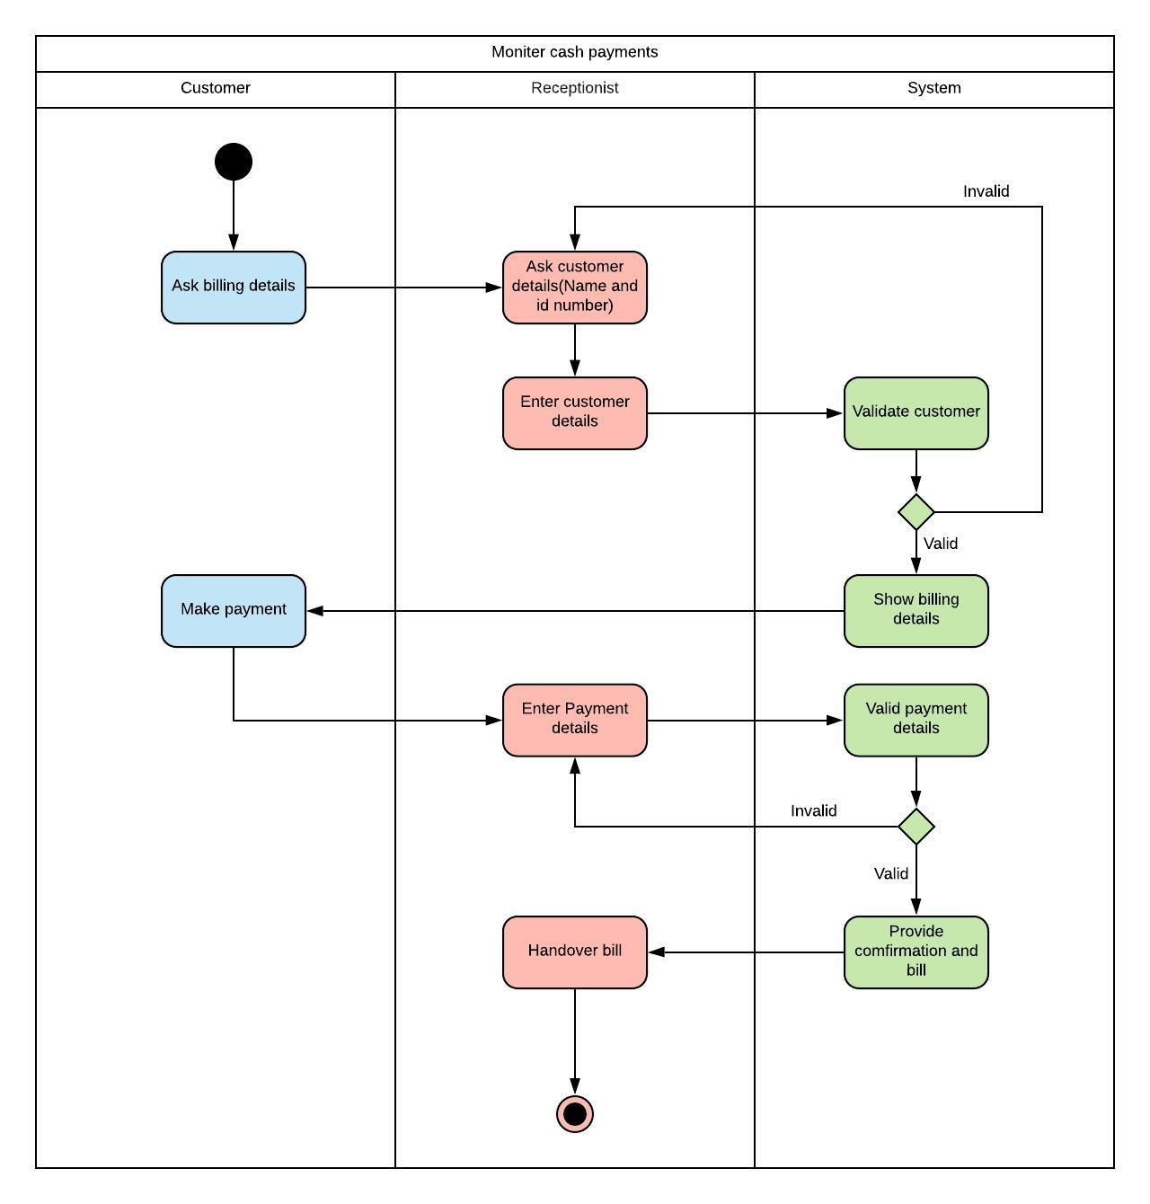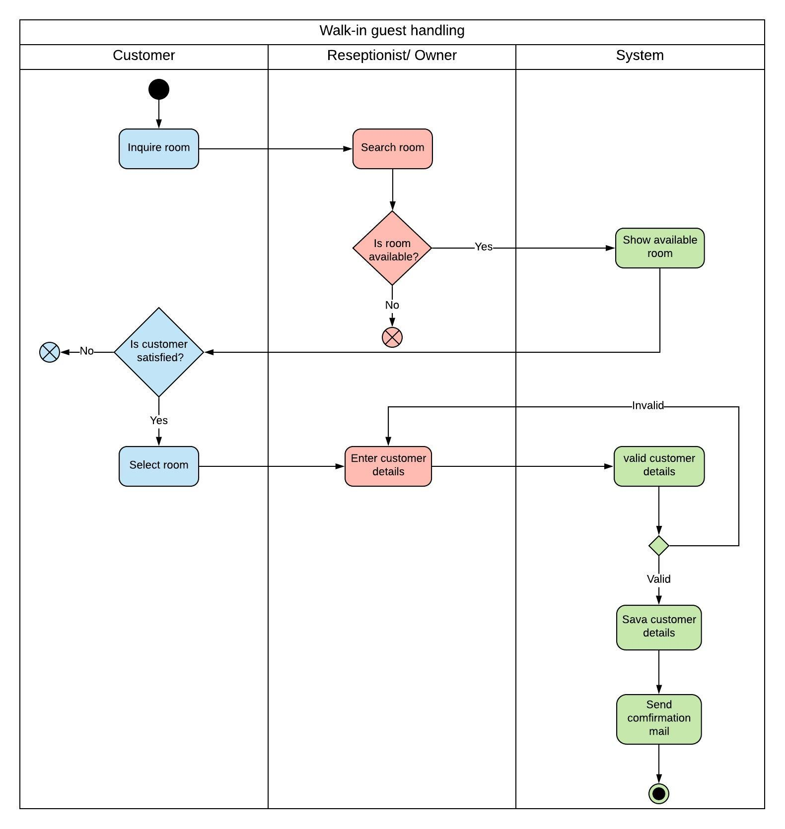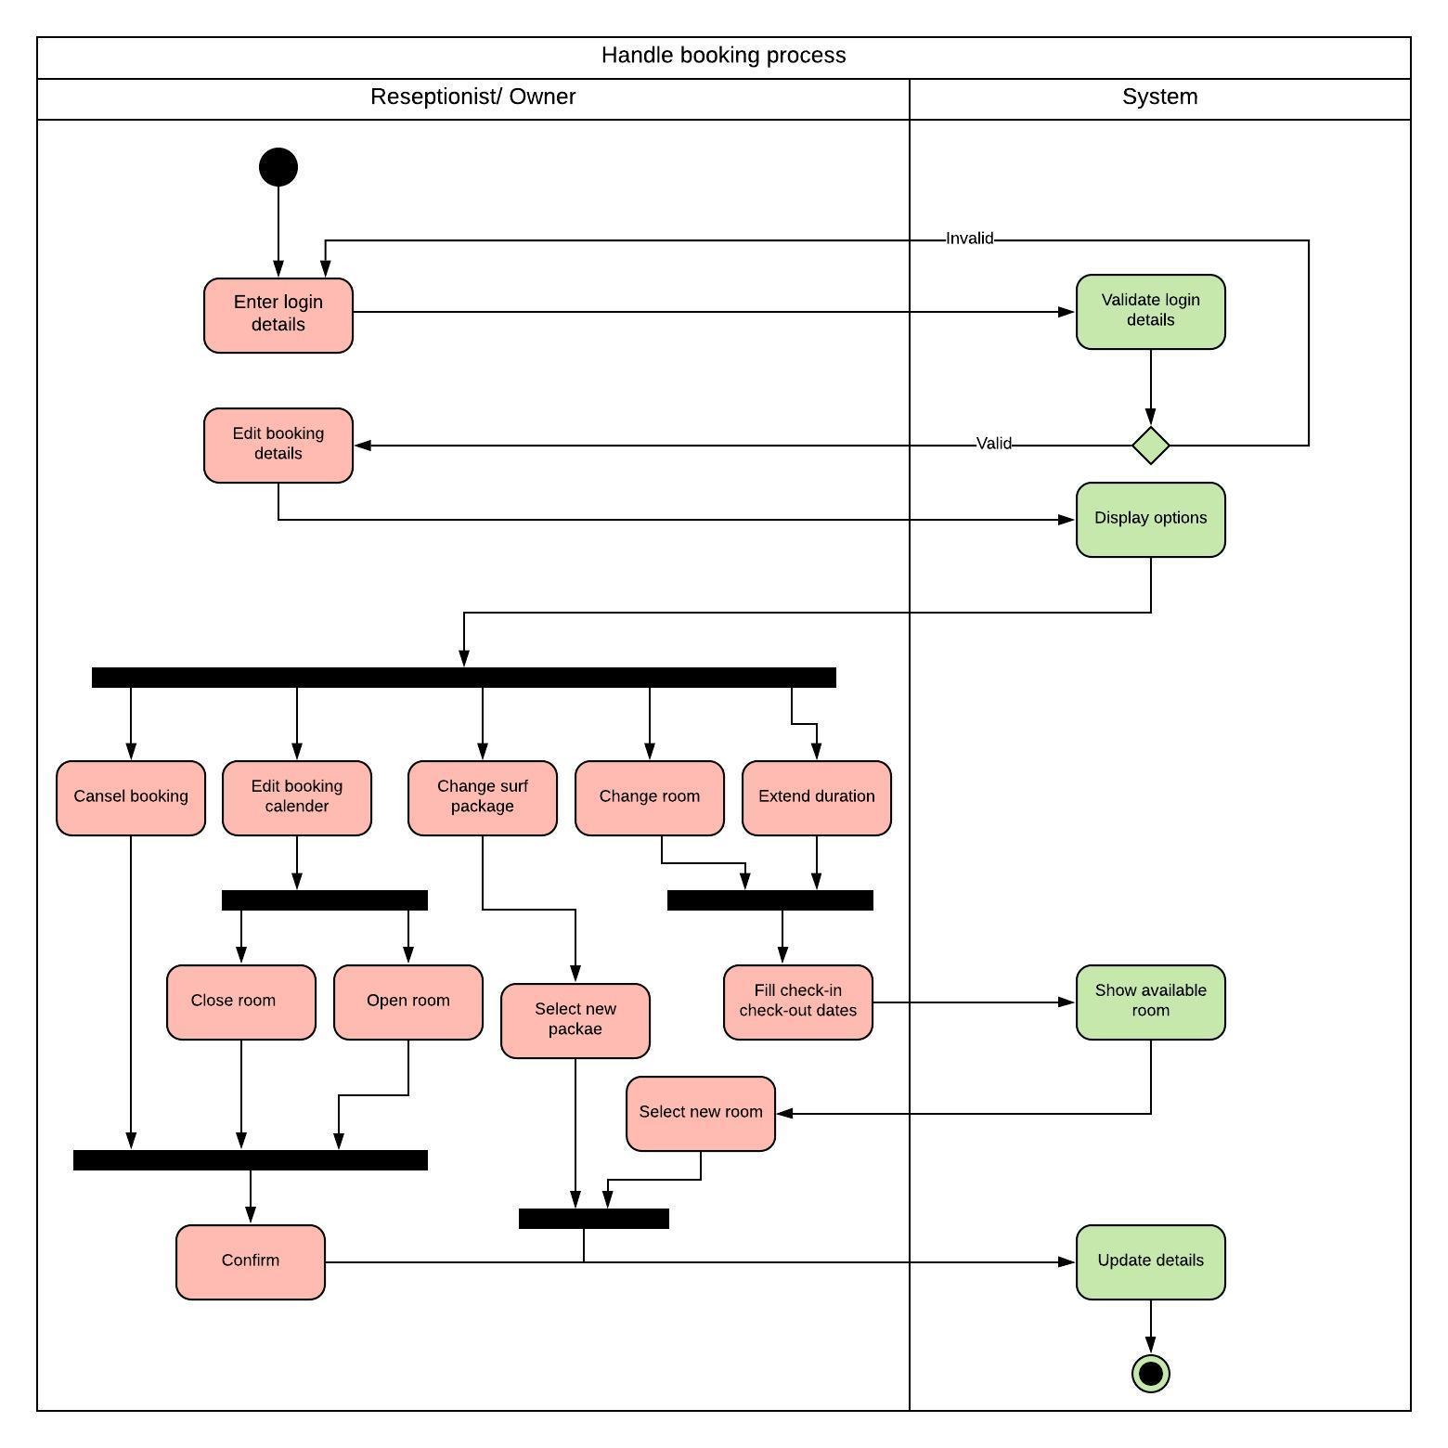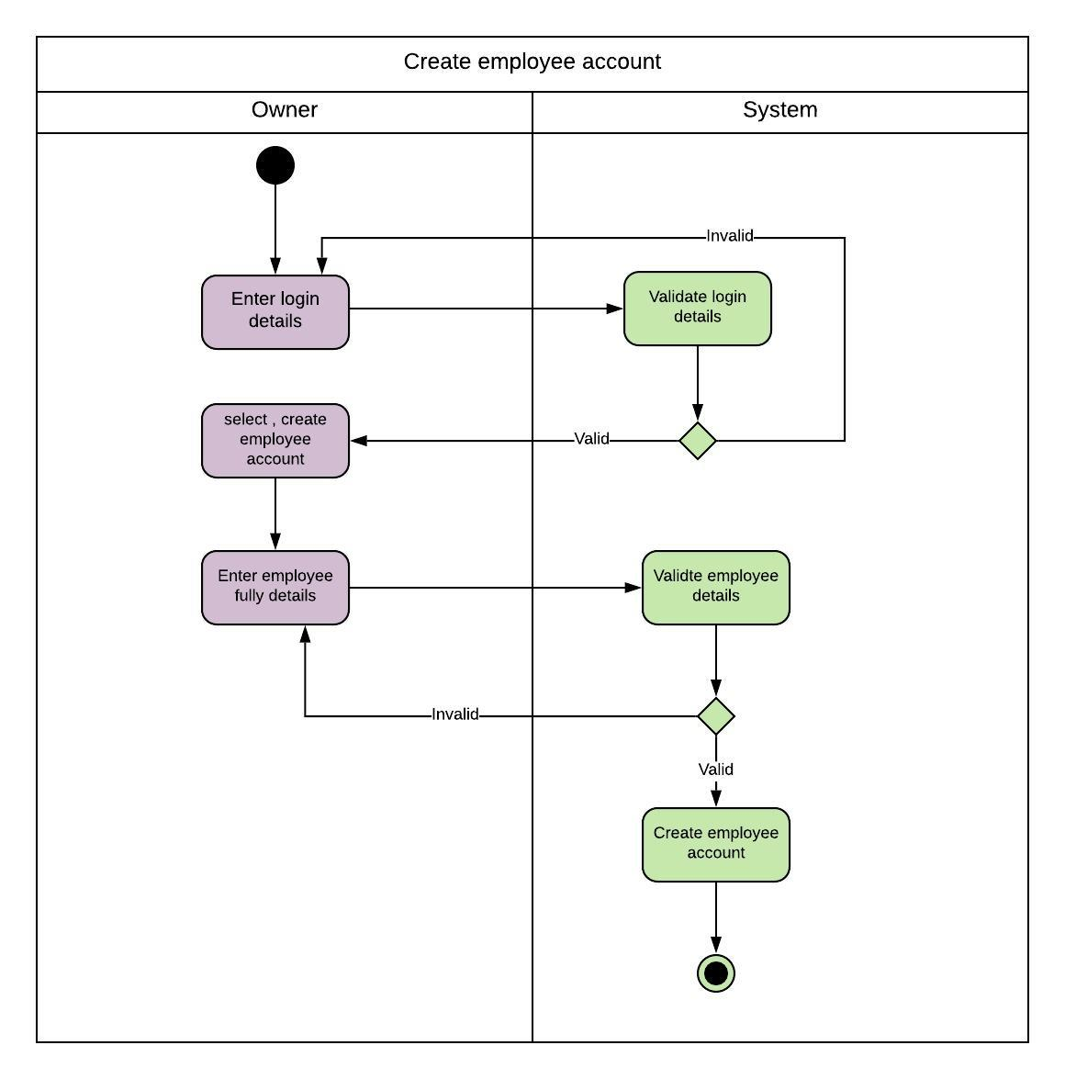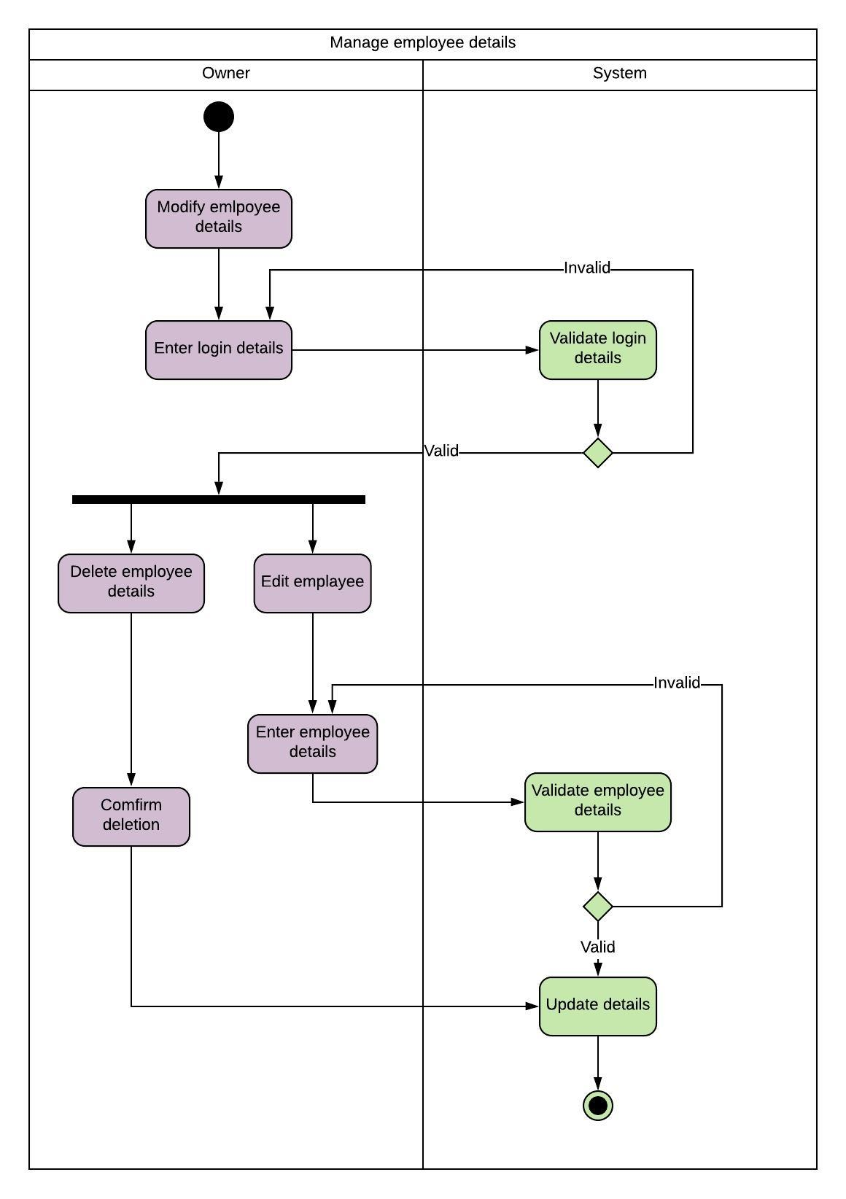 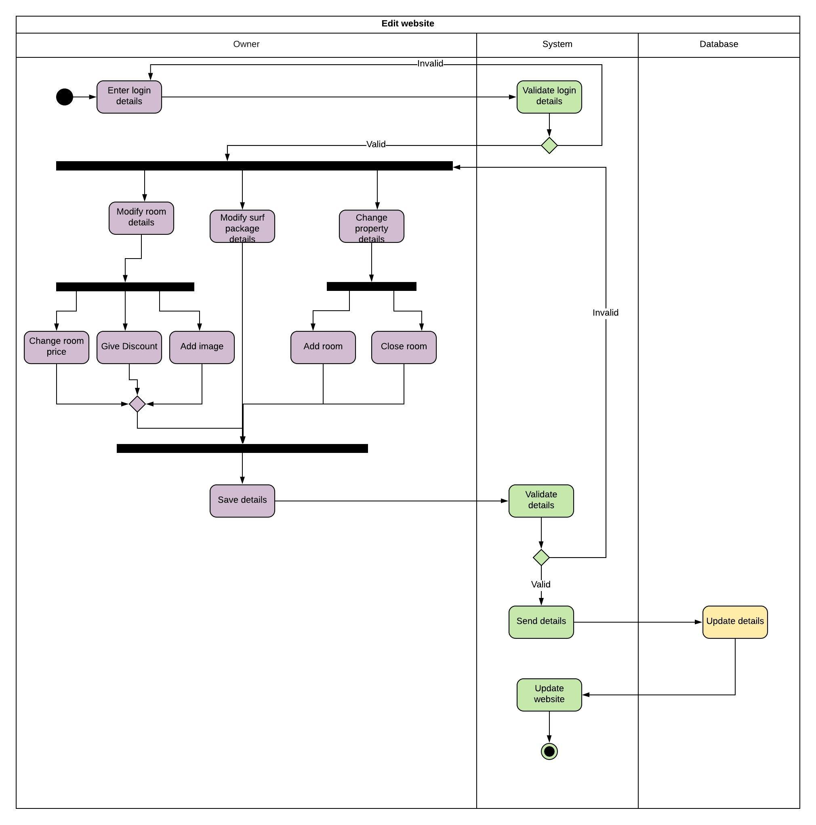 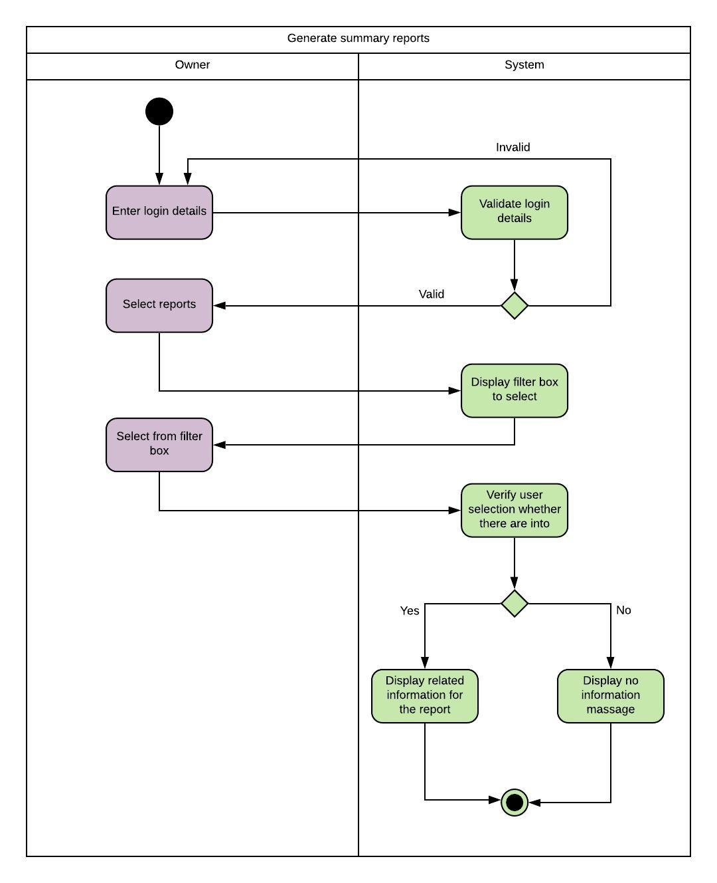

# Quality Attribute Identification

## Identification of Quality Attribute

* Security& Privacy
* Portability
* Availability
* Usability
* Reliability

## Suggestions to achieve Quality Attribute

1. Security& Privacy

Except for a process in the system such as sending unique package information or summary report generation personal data of the users and employees such as email addresses, telephone numbers are not used in any manner.

All the information is encrypted to prevent the misuse of sensitive data.

1. Portability

The software can be run in any environment or any machine.

1. Availability

The site is accessible 24 /7 and 365 days. We are using shared hosting sites such as Namecheap, GoDaddy, digital Ocean.

1. Usability

The system should be easy to use for all users. Icons and images used in the system should be visible and discernible regardless of the device used.

1. Reliability

Testing for reliability is not straightforward. It is challenging to state if a system does or does not meet reliability requirements. We hope to conduct many tests to guarantee the reliability of the system before and after the turnover.

# Technologies to be used

## Front-end

* HTML 5
* CSS 3
* JavaScript

## Back-end

* PHP
* MySQL

## Other technologies

* Adobe photoshop
* Adobe premiere pro
* GitHub
* Trello
* Git

# Project timeline

We are able to implement the solution within the allocated period, and it is shown in

the Gantt chart shown below. We are hoping to complete the implementation and testing

phases within one year.

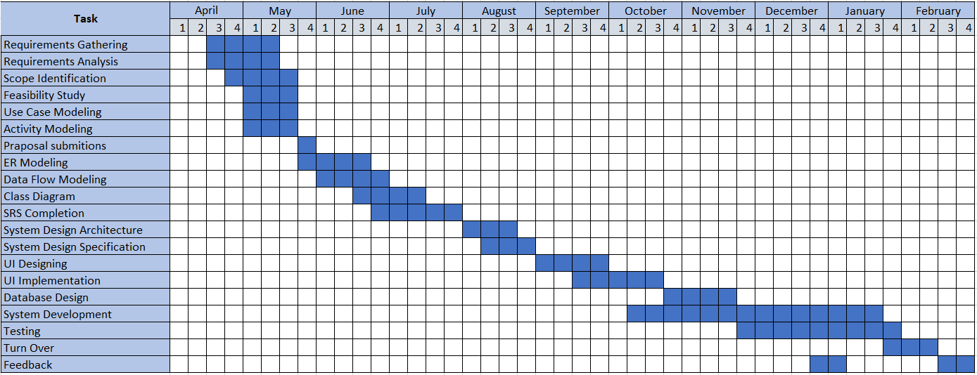

# Declaration

***We as members of the project titled "****Hotel Management System****". Certify that we will carry out this project according to the guidelines provided by the coordinators and supervisors of the course as well as we will not incorporate, without acknowledgment, any material previously submitted for a degree or diploma in any university. To the best of our knowledge and brief, the project work will not contain any material previously published or written by another person or ourselves except where due reference is made in the text of appropriate places.***

|  |  |  |  |  |  |
| --- | --- | --- | --- | --- | --- |
| |  |  |  | | --- | --- | --- | | Index Number |  |  | | Name of the Student | Signature |
| 18001327 | R.P.Ranaweera |  |
| 18000576 | W.T.Gihan |  |
| 18001823 | G.G.N.N.Wanigasekara |  |
| 18001696 | H.M.D.Thathsara |  |